|  |  |
| --- | --- |
| Riferimento |  |
| Versione | 0.1 |
| Data | 25/01/2020 |
| Destinatario | Prof.ssa F. Ferrucci |
| Presentato da | Marco Delle Cave, Francesco Pagano,  Manuel Pisciotta, Alessia Olivieri |
| Approvato da |  |



Test Execution Report

TutoratoSmart

Revision History

|  |  |  |  |
| --- | --- | --- | --- |
| **Data** | **Versione** | **Cambiamenti** | **Autori** |
| 25/01/2020 | 0.1 | Prima stesura | Delle Cave Marco,  Pagano Francesco, Pisciotta Manuel |

Sommario

1. User 4

**1.1 LoginEmailEmpty 4**

**1.2 LoginEmailFormatError 5**

**1.3 LoginPasswordEmpty 6**

**1.4 LoginPasswordFormatError 7**

**1.5 LoginSuccessCommission 8**

**1.6 LoginSuccessStudent 9**

**1.7 LoginSuccessTutor 10**

**1.8 RegistrationNameFormatError 11**

**1.9 RegistrationPasswordsDifferentError 12**

**1.10 RegistrationStudentSuccess 13**

2. Tutoring_Request 14

**2.1 AddRequestError 14**

**2.2 AddRequestSuccess 15**

**2.3 ModifyRequestError 16**

**2.4 ModifyRequestSuccess 17**

3. Request_Management 18

**3.1 AddAppointmentError 18**

**3.2 AddAppointmentSuccess 19**

**3.3 ManageRequestError 20**

**3.4 ManageRequestSuccess 21**

**3.5 ModifyAppointmentError 22**

**3.6 ModifyAppointmentSuccess 23**

4. Tutoring_Activity_Management 24

**4.1 AddActivityError 24**

**4.2 AddActivitySuccess 25**

**4.3 ModifyActivityError 26**

**4.4 ModifyActivitySuccess 27**

5. Tutoring_Supervision 28

**5.1 RegistrationTutorSuccess 28**

# 1. User

## 1.1 LoginEmailEmpty

|  |  |  |
| --- | --- | --- |
| **NOME** | LoginEmailEmpty | |
| **DATA** | 25/01/20 | |
| **OUTPUT ATTESO** | | |
| Errore | | |
| **OUTPUT SISTEMA** | | |
| Errore | | |
| **ESITO** | | Corretto |

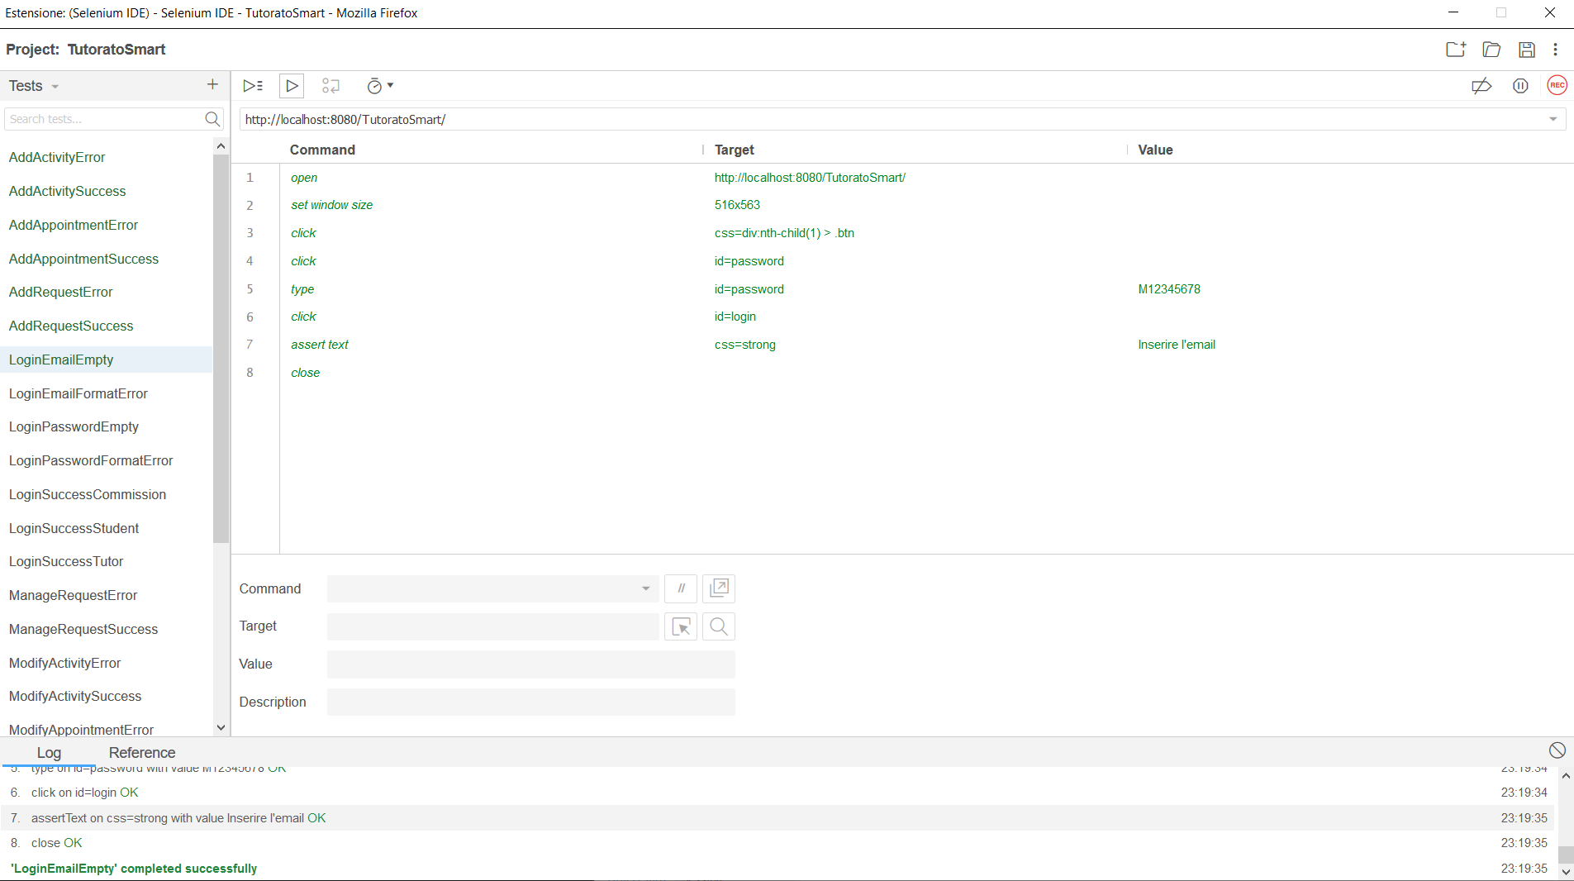

## 1.2 LoginEmailFormatError

|  |  |  |
| --- | --- | --- |
| **NOME** | LoginEmailFormatError | |
| **DATA** | 25/01/20 | |
| **OUTPUT ATTESO** | | |
| Errore | | |
| **OUTPUT SISTEMA** | | |
| Errore | | |
| **ESITO** | | Corretto |

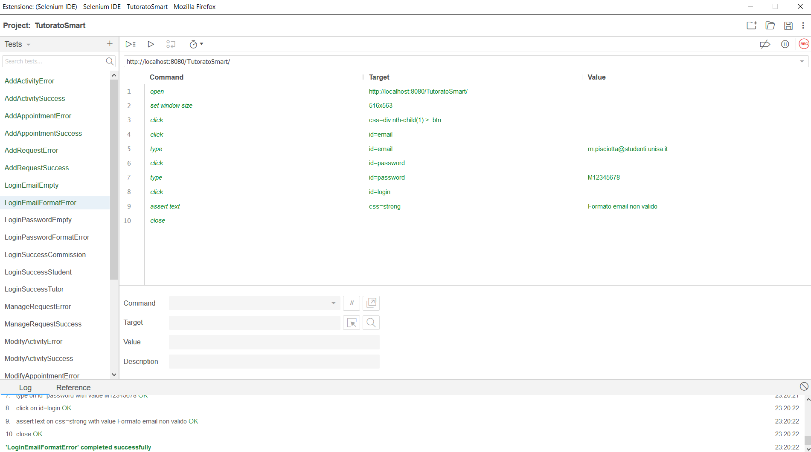

## 1.3 LoginPasswordEmpty

|  |  |  |
| --- | --- | --- |
| **NOME** | LoginPasswordEmpty | |
| **DATA** | 25/01/20 | |
| **OUTPUT ATTESO** | | |
| Errore | | |
| **OUTPUT SISTEMA** | | |
| Errore | | |
| **ESITO** | | Corretto |

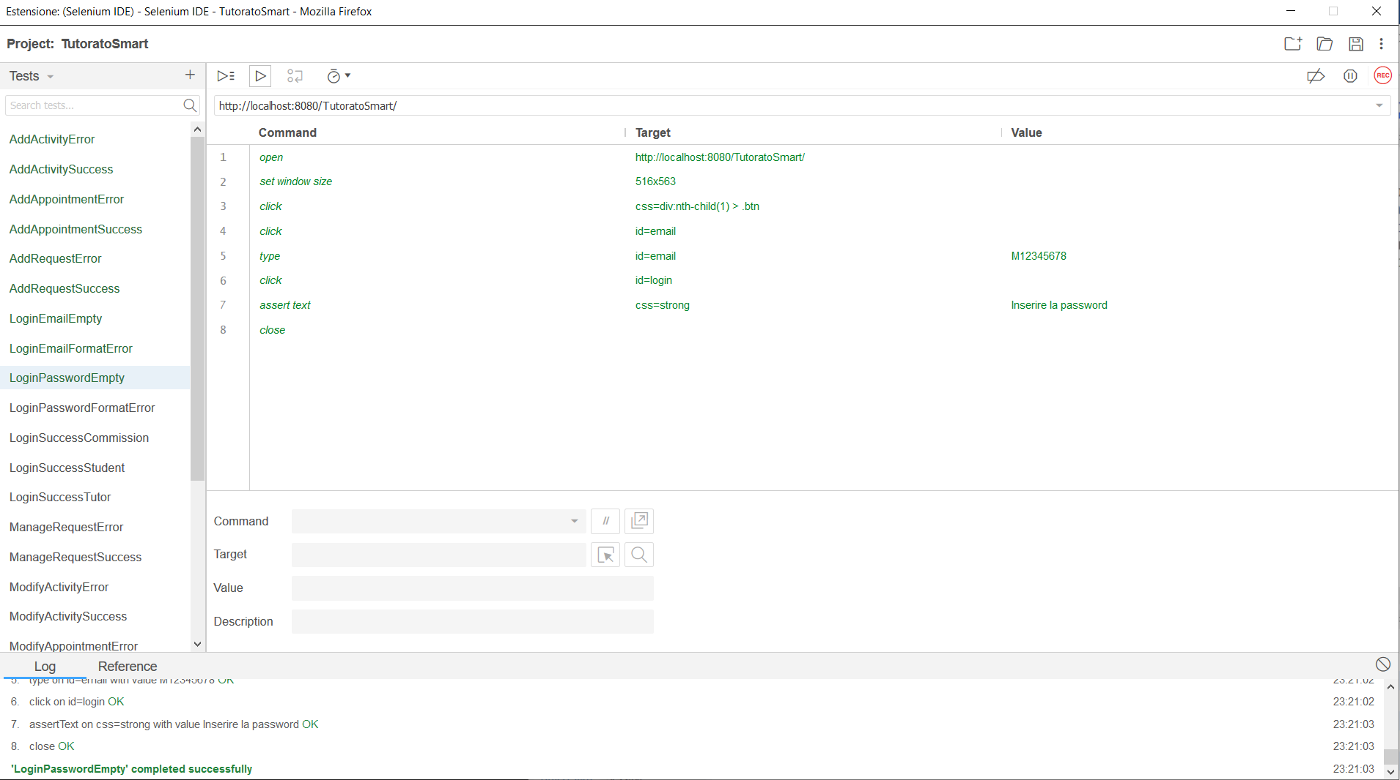

## 1.4 LoginPasswordFormatError

|  |  |  |
| --- | --- | --- |
| **NOME** | LoginPasswordFormatError | |
| **DATA** | 25/01/20 | |
| **OUTPUT ATTESO** | | |
| Errore | | |
| **OUTPUT SISTEMA** | | |
| Errore | | |
| **ESITO** | | Corretto |

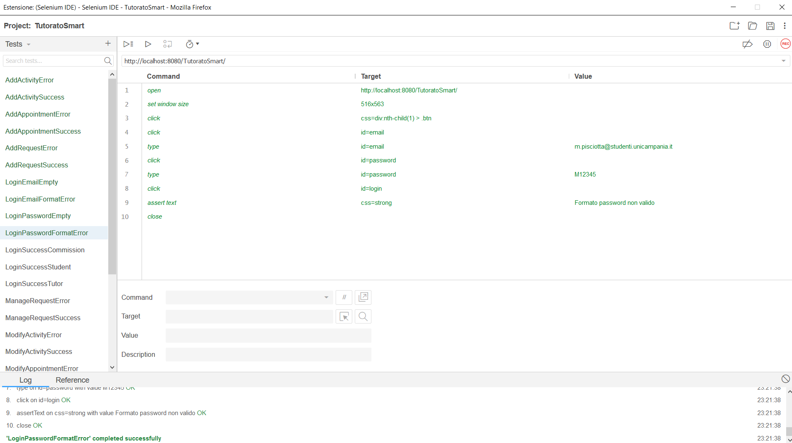

## 1.5 LoginSuccessCommission

|  |  |  |
| --- | --- | --- |
| **NOME** | LoginSuccessCommission | |
| **DATA** | 25/01/20 | |
| **OUTPUT ATTESO** | | |
| Corretto | | |
| **OUTPUT SISTEMA** | | |
| Corretto | | |
| **ESITO** | | Corretto |

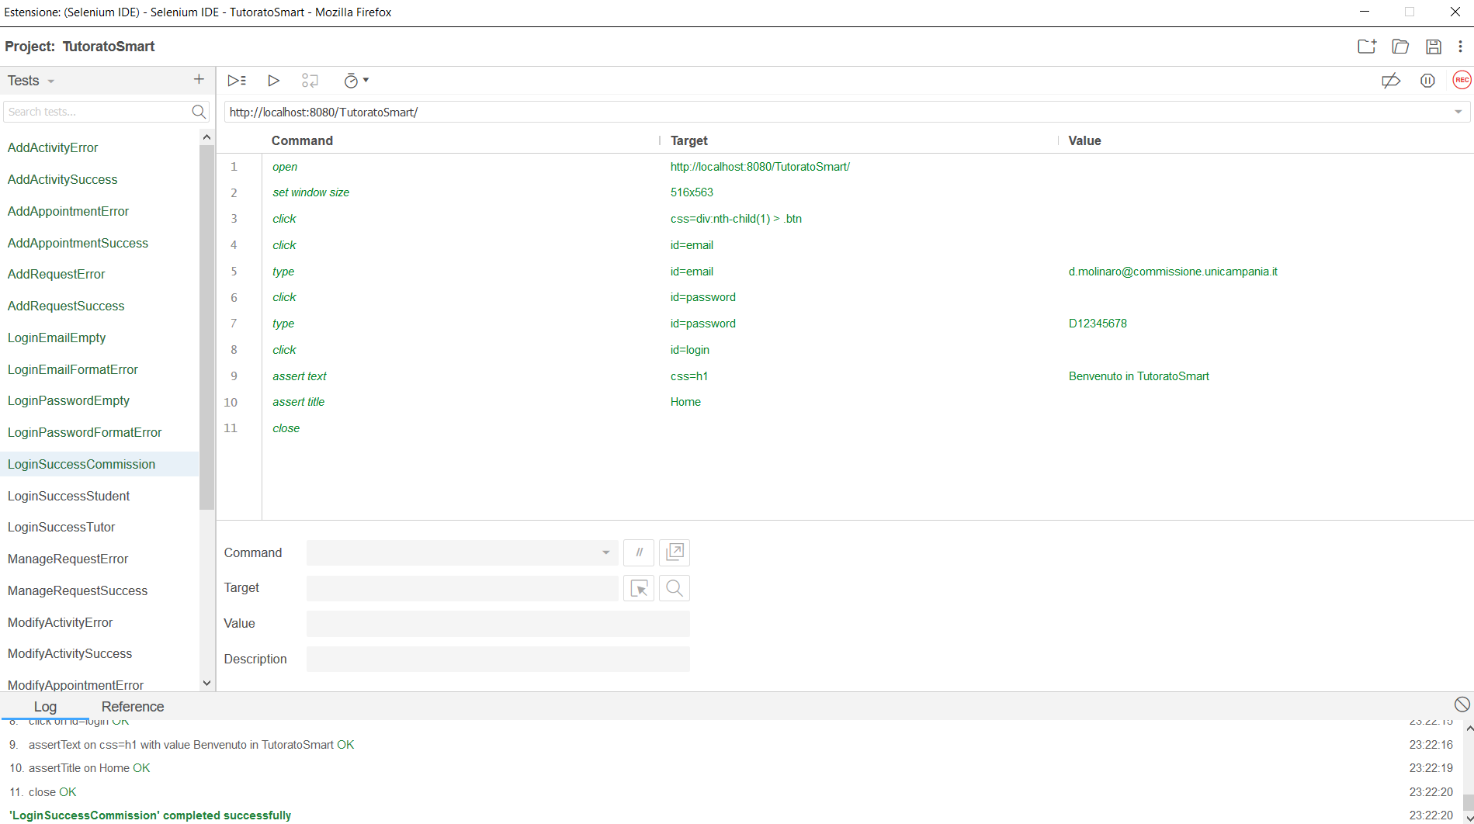

## 1.6 LoginSuccessStudent

|  |  |  |
| --- | --- | --- |
| **NOME** | LoginSuccessStudent | |
| **DATA** | 25/01/20 | |
| **OUTPUT ATTESO** | | |
| Corretto | | |
| **OUTPUT SISTEMA** | | |
| Corretto | | |
| **ESITO** | | Corretto |

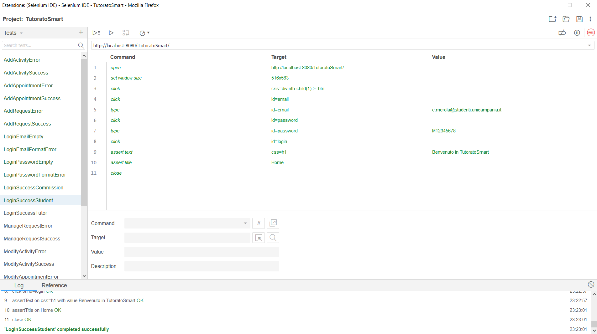

## 1.7 LoginSuccessTutor

|  |  |  |
| --- | --- | --- |
| **NOME** | LoginSuccessTutor | |
| **DATA** | 25/01/20 | |
| **OUTPUT ATTESO** | | |
| Corretto | | |
| **OUTPUT SISTEMA** | | |
| Corretto | | |
| **ESITO** | | Corretto |

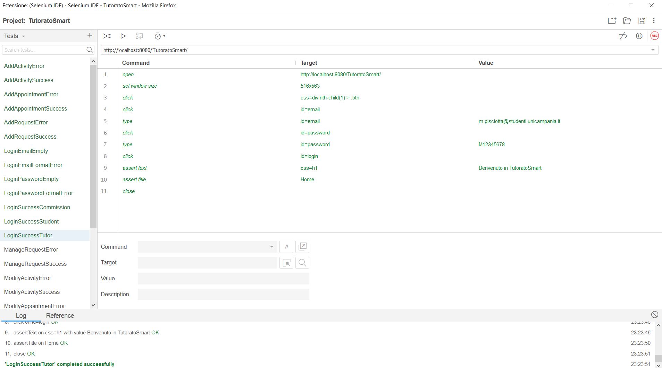

## 1.8 RegistrationNameFormatError

|  |  |  |
| --- | --- | --- |
| **NOME** | RegistrationNameFormatError | |
| **DATA** | 25/01/20 | |
| **OUTPUT ATTESO** | | |
| Errore | | |
| **OUTPUT SISTEMA** | | |
| Errore | | |
| **ESITO** | | Corretto |

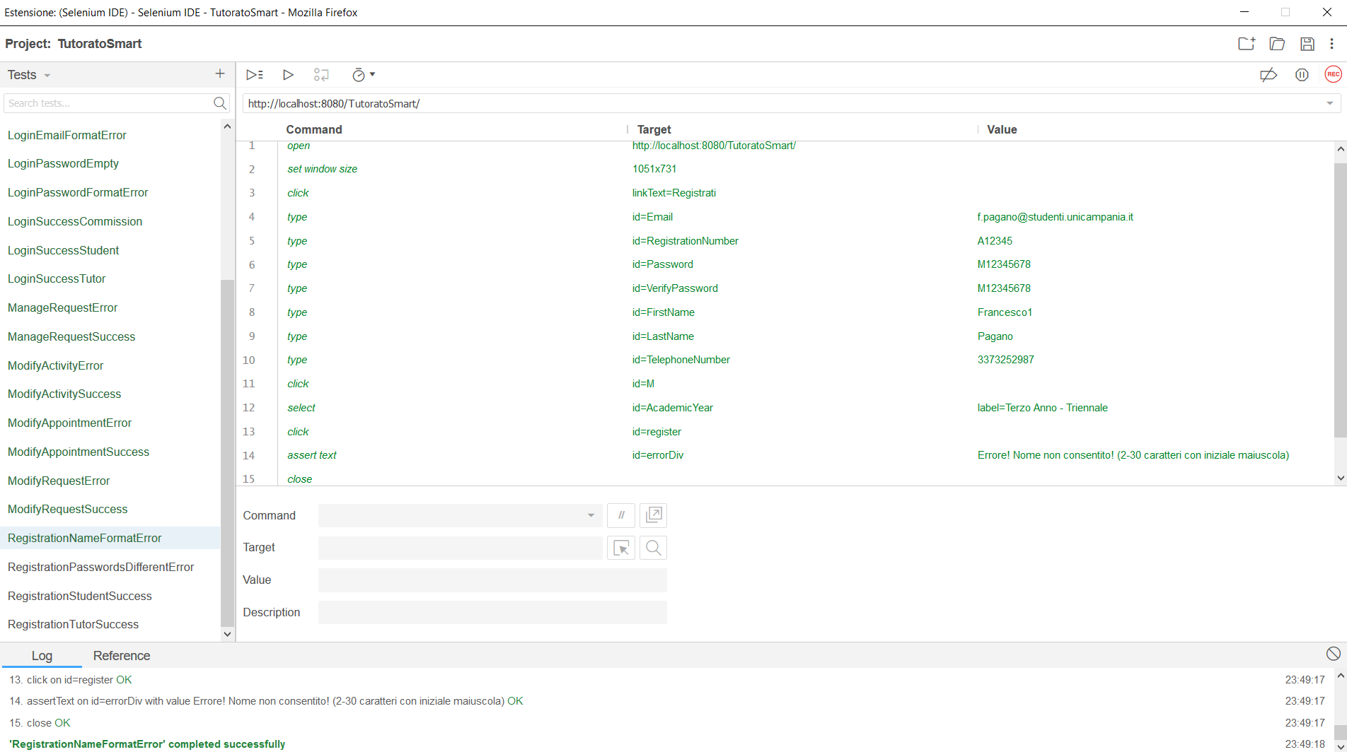

## 1.9 RegistrationPasswordsDifferentError

|  |  |  |
| --- | --- | --- |
| **NOME** | RegistrationPasswordsDifferentError | |
| **DATA** | 25/01/20 | |
| **OUTPUT ATTESO** | | |
| Errore | | |
| **OUTPUT SISTEMA** | | |
| Errore | | |
| **ESITO** | | Corretto |

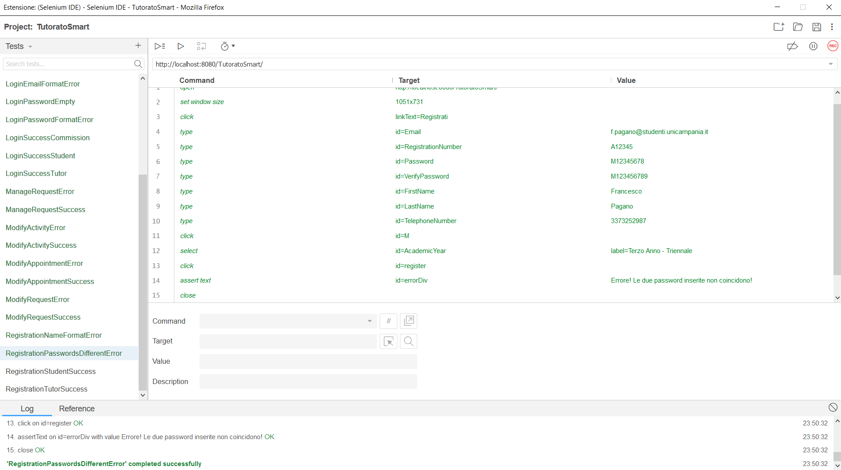

## 1.10 RegistrationStudentSuccess

|  |  |  |
| --- | --- | --- |
| **NOME** | RegistrationStudentSuccess | |
| **DATA** | 25/01/20 | |
| **OUTPUT ATTESO** | | |
| Errore | | |
| **OUTPUT SISTEMA** | | |
| Errore | | |
| **ESITO** | | Corretto |

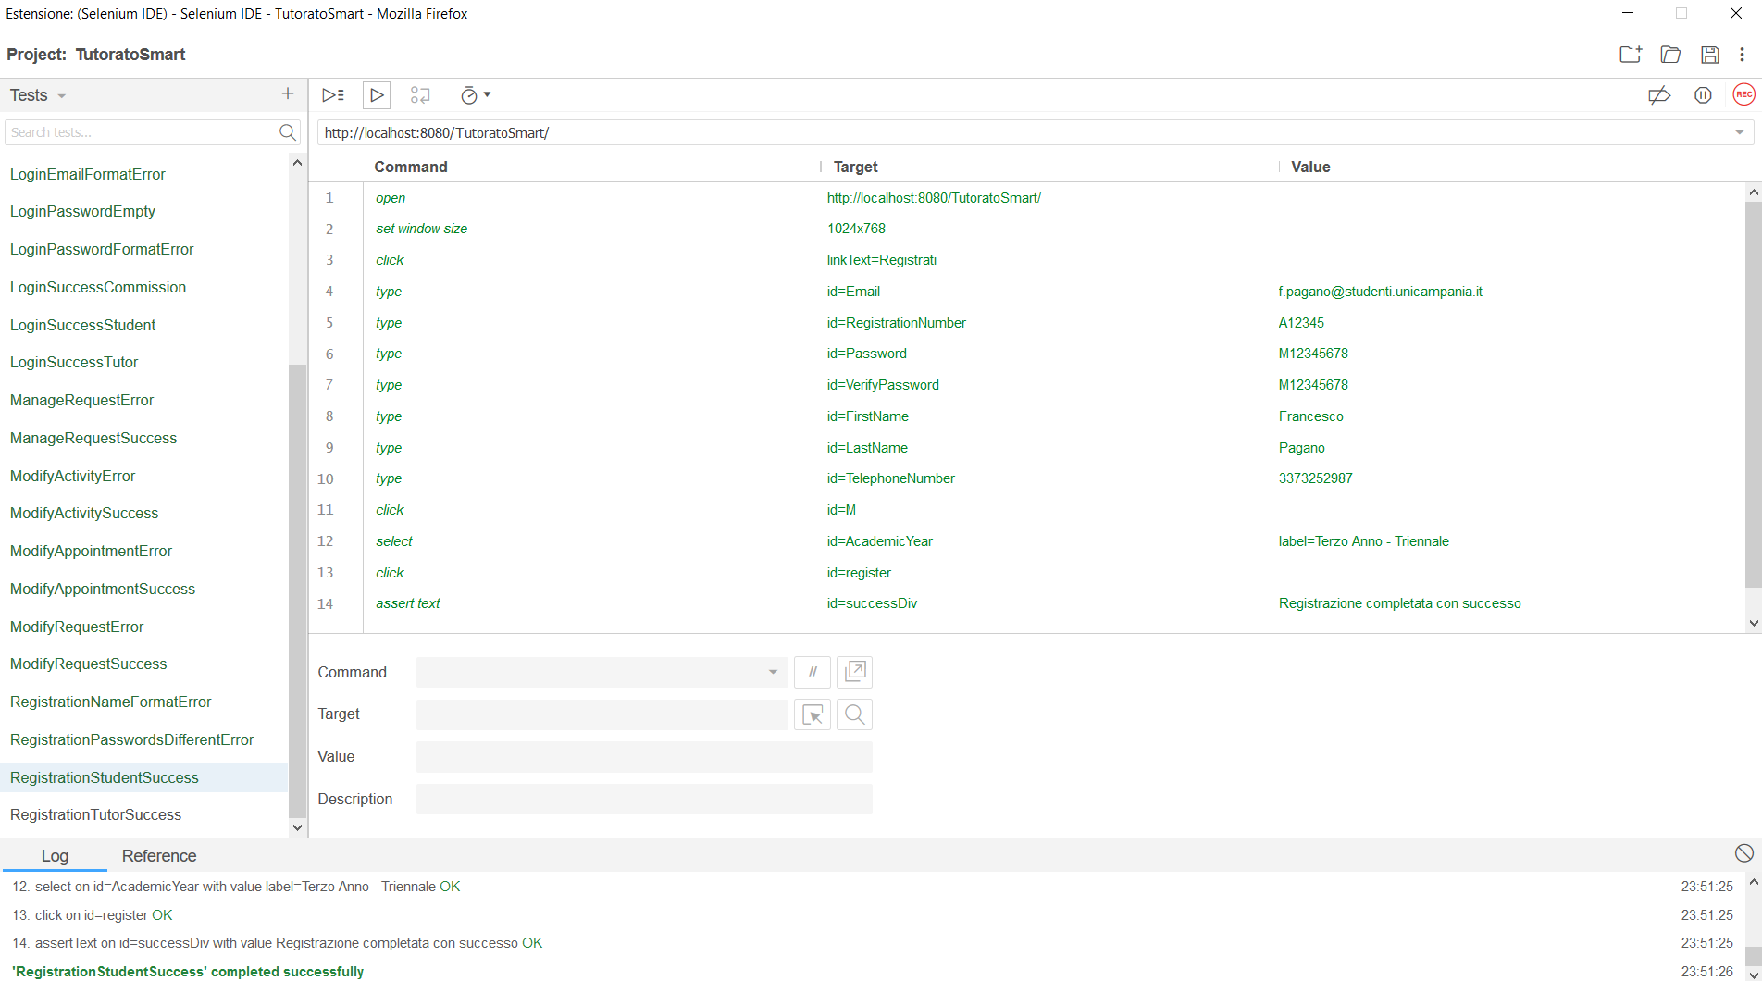

# 2. Tutoring_Request

## 2.1 AddRequestError

|  |  |  |
| --- | --- | --- |
| **NOME** | AddRequestError | |
| **DATA** | 25/01/20 | |
| **OUTPUT ATTESO** | | |
| Errore | | |
| **OUTPUT SISTEMA** | | |
| Errore | | |
| **ESITO** | | Corretto |

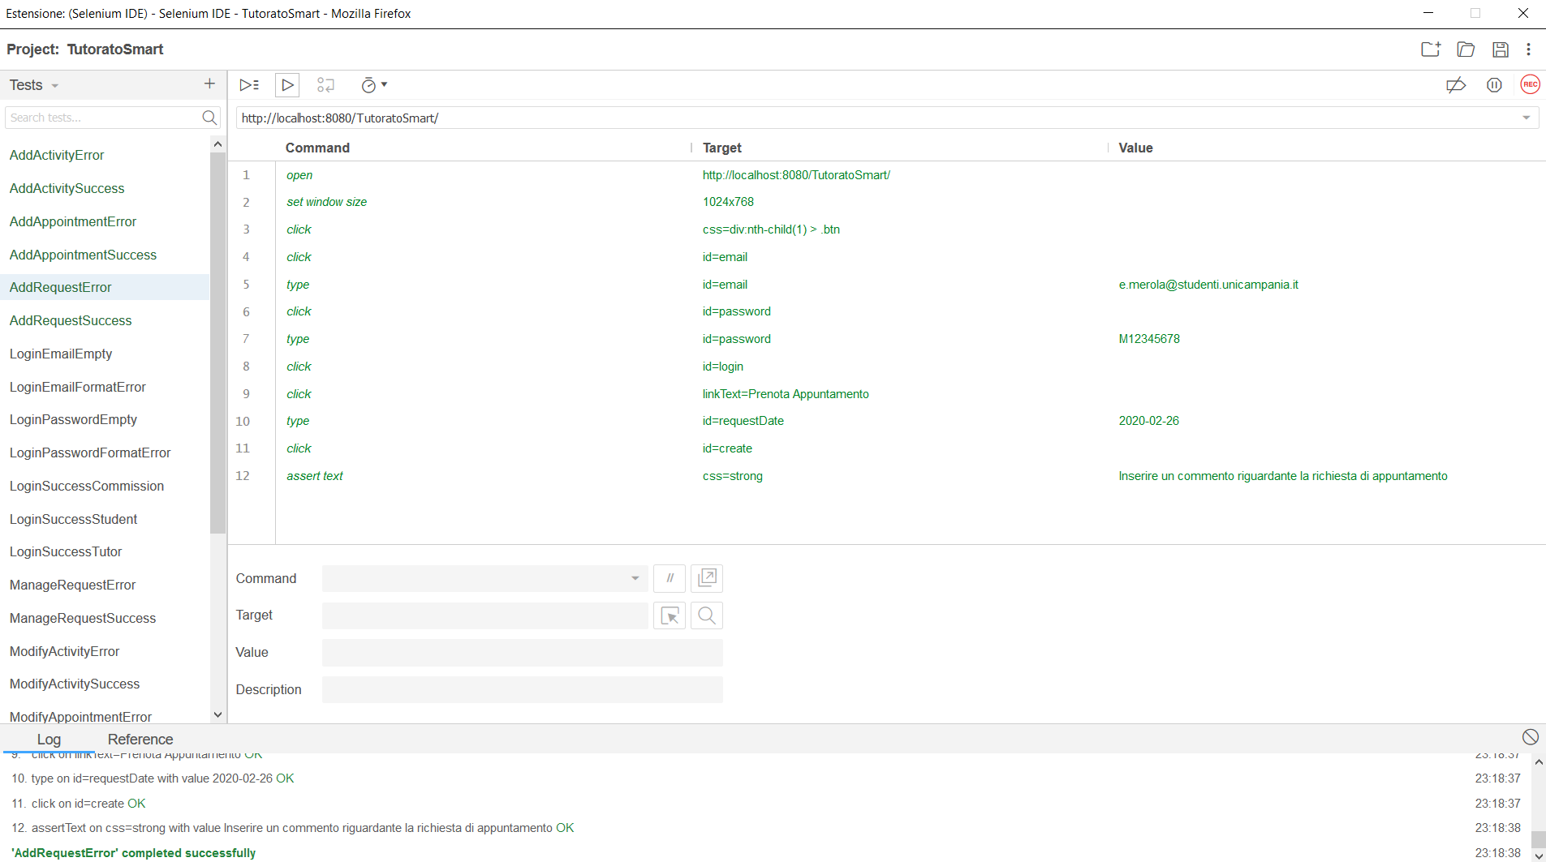

## 2.2 AddRequestSuccess

|  |  |  |
| --- | --- | --- |
| **NOME** | AddRequestSuccess | |
| **DATA** | 25/01/20 | |
| **OUTPUT ATTESO** | | |
| Corretto | | |
| **OUTPUT SISTEMA** | | |
| Corretto | | |
| **ESITO** | | Corretto |

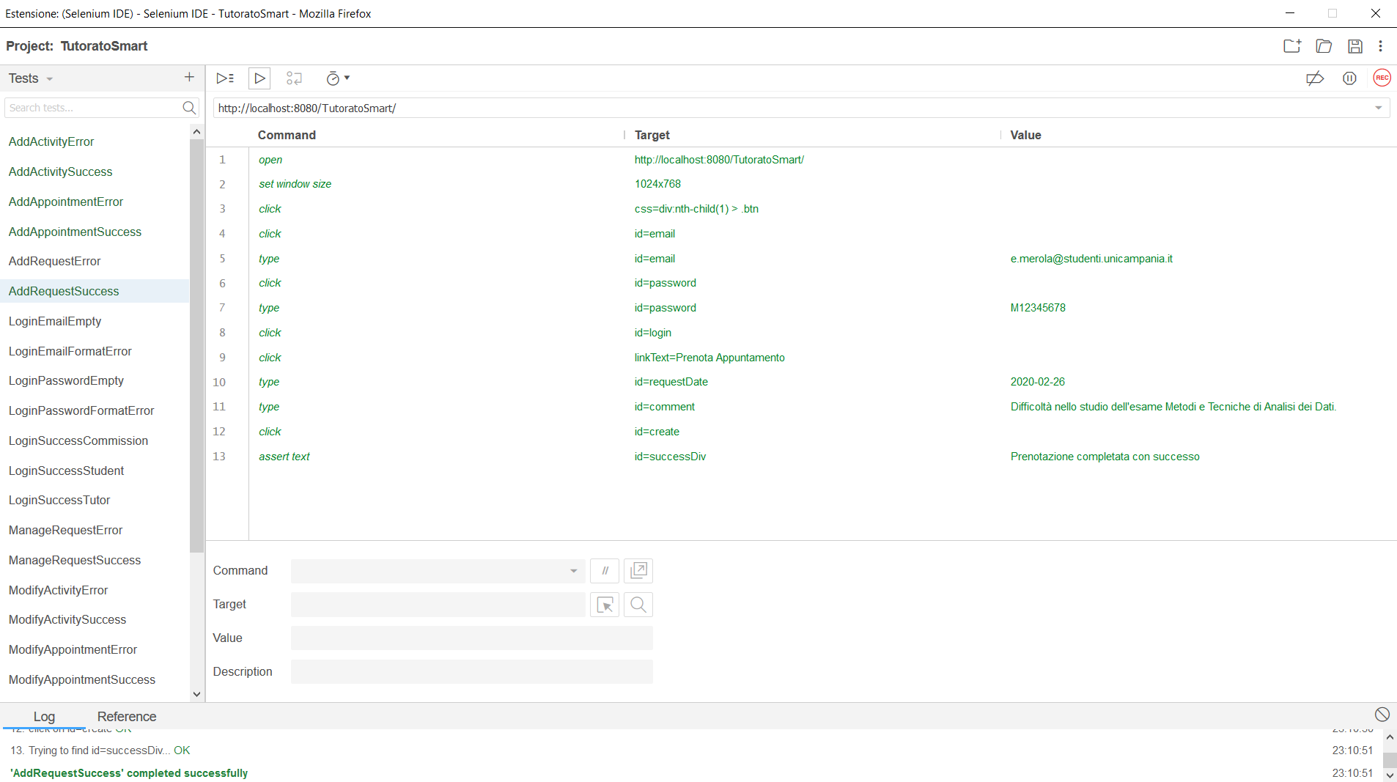

## 2.3 ModifyRequestError

|  |  |  |
| --- | --- | --- |
| **NOME** | ModifyRequestError | |
| **DATA** | 25/01/20 | |
| **OUTPUT ATTESO** | | |
| Errore | | |
| **OUTPUT SISTEMA** | | |
| Errore | | |
| **ESITO** | | Corretto |

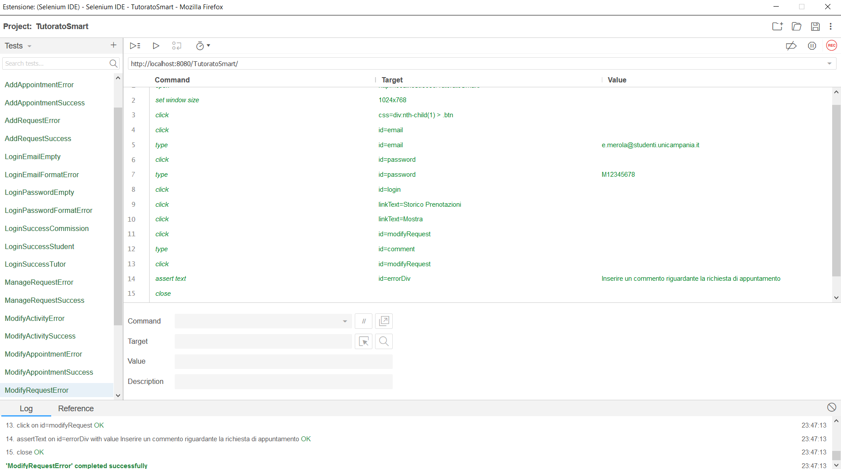

## 2.4 ModifyRequestSuccess

|  |  |  |
| --- | --- | --- |
| **NOME** | ModifyRequestSuccess | |
| **DATA** | 25/01/20 | |
| **OUTPUT ATTESO** | | |
| Corretto | | |
| **OUTPUT SISTEMA** | | |
| Corretto | | |
| **ESITO** | | Corretto |

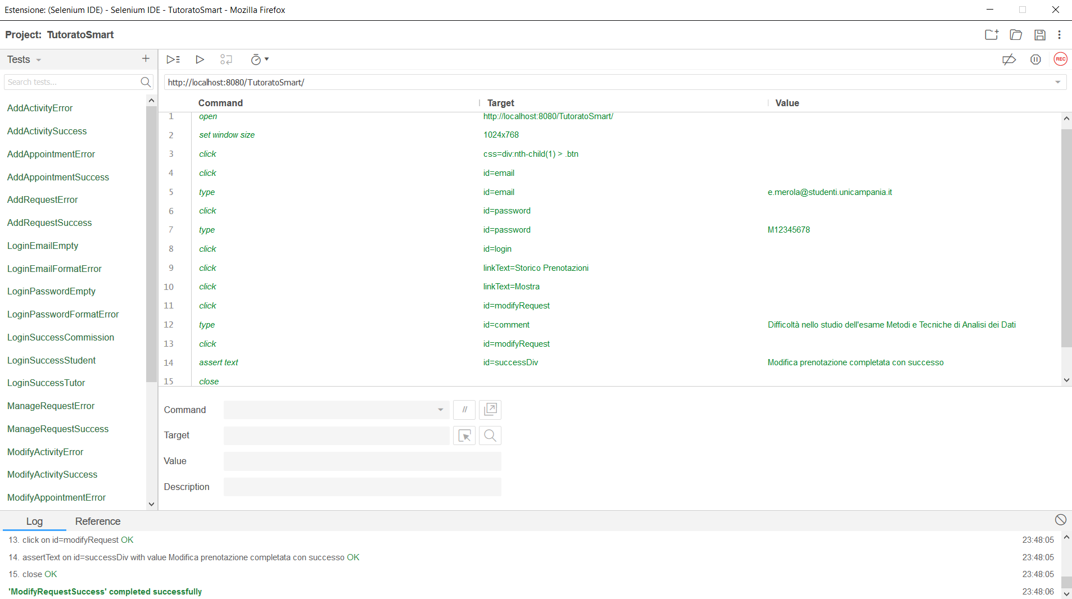

# 3. Request_Management

## 3.1 AddAppointmentError

|  |  |  |
| --- | --- | --- |
| **NOME** | AddAppointmentError | |
| **DATA** | 25/01/20 | |
| **OUTPUT ATTESO** | | |
| Errore | | |
| **OUTPUT SISTEMA** | | |
| Errore | | |
| **ESITO** | | Corretto |

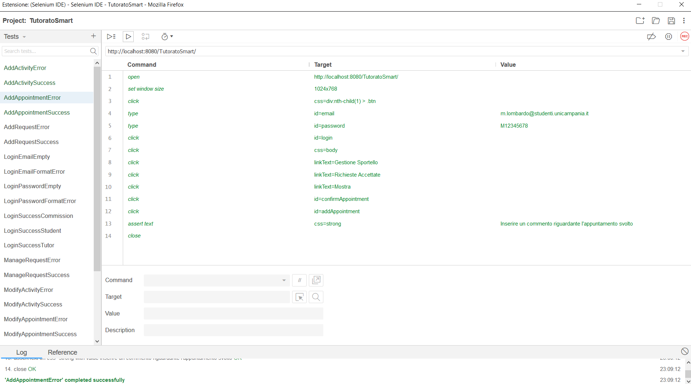

## 3.2 AddAppointmentSuccess

|  |  |  |
| --- | --- | --- |
| **NOME** | AddAppointmentSuccess | |
| **DATA** | 25/01/20 | |
| **OUTPUT ATTESO** | | |
| Corretto | | |
| **OUTPUT SISTEMA** | | |
| Corretto | | |
| **ESITO** | | Corretto |

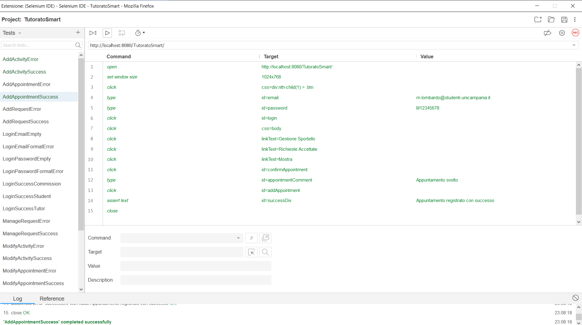

## 3.3 ManageRequestError

|  |  |  |
| --- | --- | --- |
| **NOME** | ManageRequestError | |
| **DATA** | 25/01/20 | |
| **OUTPUT ATTESO** | | |
| Errore | | |
| **OUTPUT SISTEMA** | | |
| Errore | | |
| **ESITO** | | Corretto |

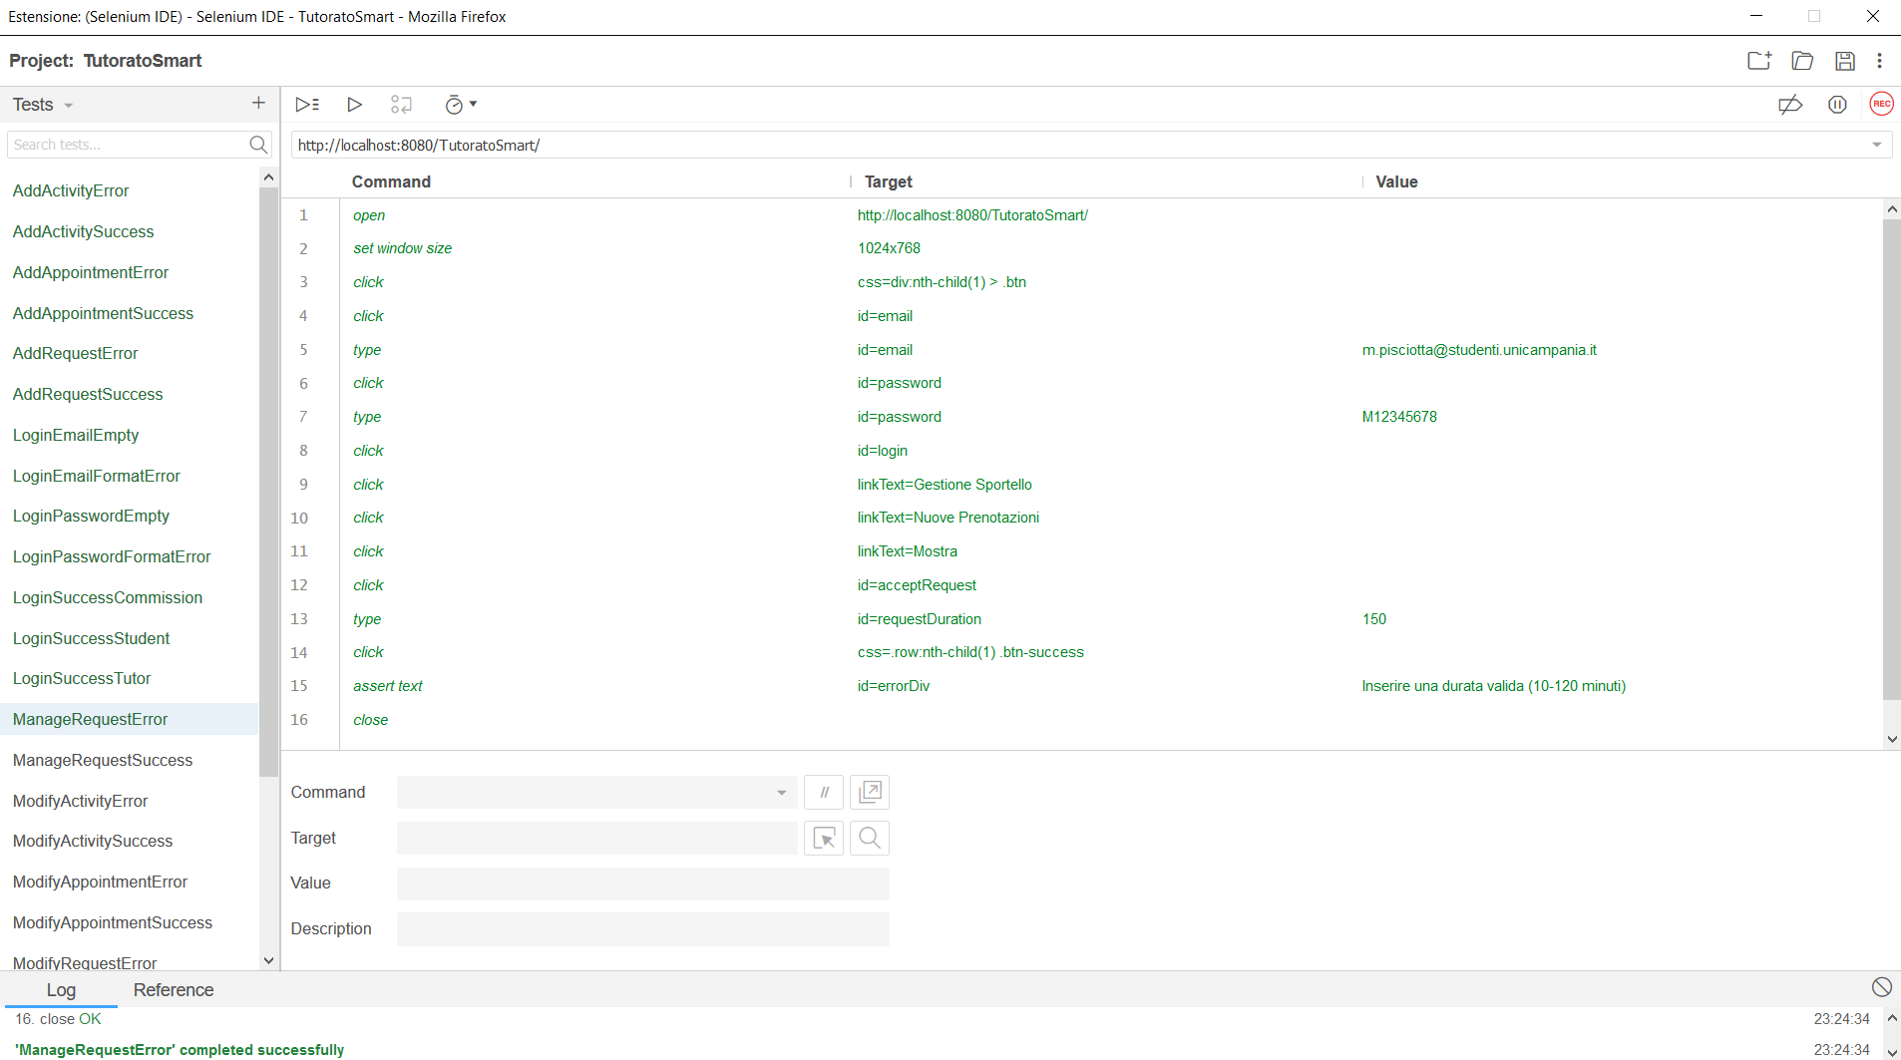

## 3.4 ManageRequestSuccess

|  |  |  |
| --- | --- | --- |
| **NOME** | ManageRequestSuccess | |
| **DATA** | 25/01/20 | |
| **OUTPUT ATTESO** | | |
| Corretto | | |
| **OUTPUT SISTEMA** | | |
| Corretto | | |
| **ESITO** | | Corretto |

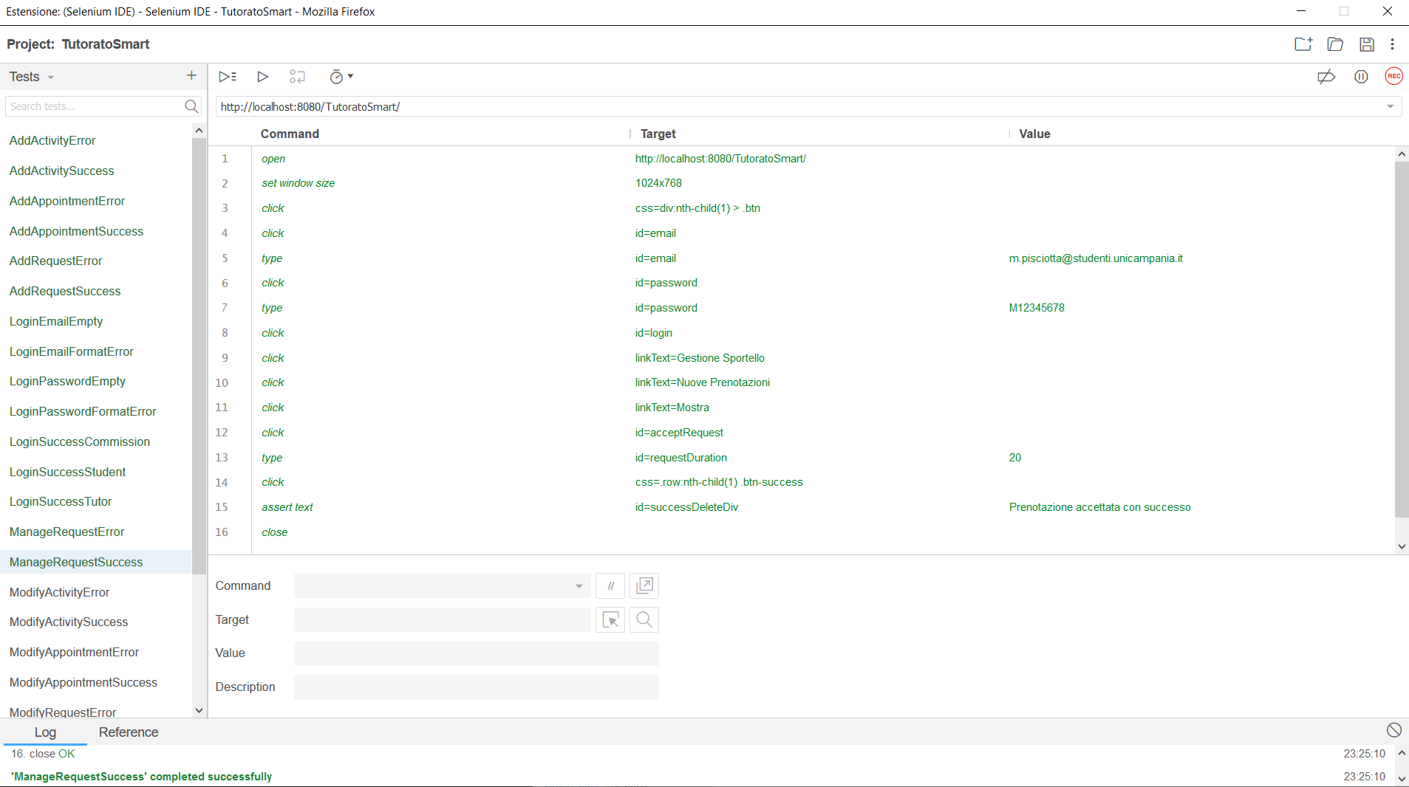

## 3.5 ModifyAppointmentError

|  |  |  |
| --- | --- | --- |
| **NOME** | ModifyAppointmentError | |
| **DATA** | 25/01/20 | |
| **OUTPUT ATTESO** | | |
| Errore | | |
| **OUTPUT SISTEMA** | | |
| Errore | | |
| **ESITO** | | Corretto |

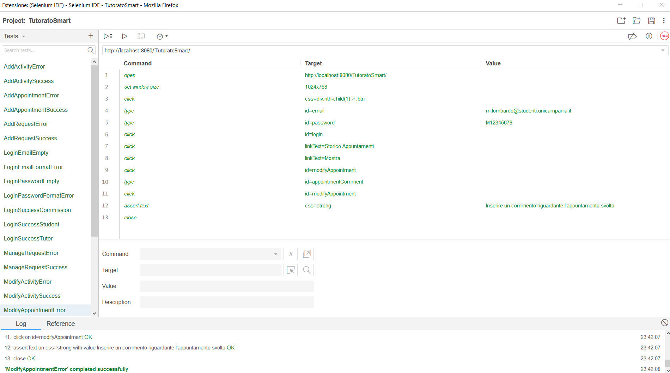

## 3.6 ModifyAppointmentSuccess

|  |  |  |
| --- | --- | --- |
| **NOME** | ModifyAppintmentSuccess | |
| **DATA** | 25/01/20 | |
| **OUTPUT ATTESO** | | |
| Corretto | | |
| **OUTPUT SISTEMA** | | |
| Corretto | | |
| **ESITO** | | Corretto |

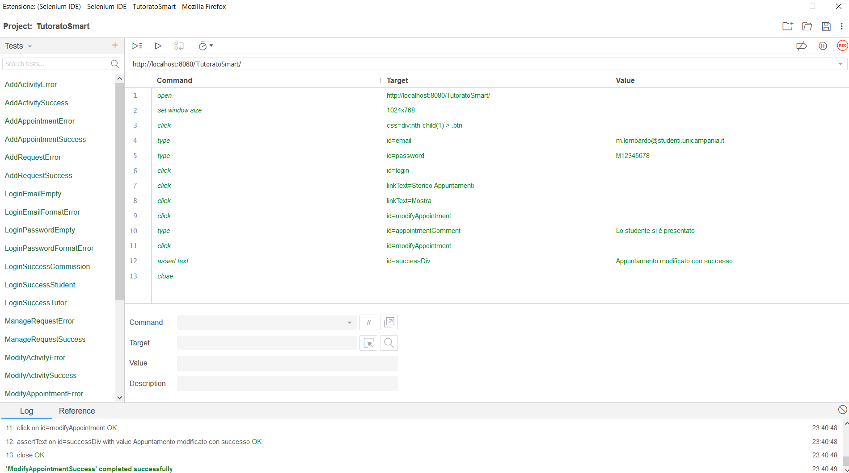

# 4. Tutoring_Activity_Management

## 4.1 AddActivityError

|  |  |  |
| --- | --- | --- |
| **NOME** | AddActivityError | |
| **DATA** | 25/01/20 | |
| **OUTPUT ATTESO** | | |
| Errore | | |
| **OUTPUT SISTEMA** | | |
| Errore | | |
| **ESITO** | | Corretto |

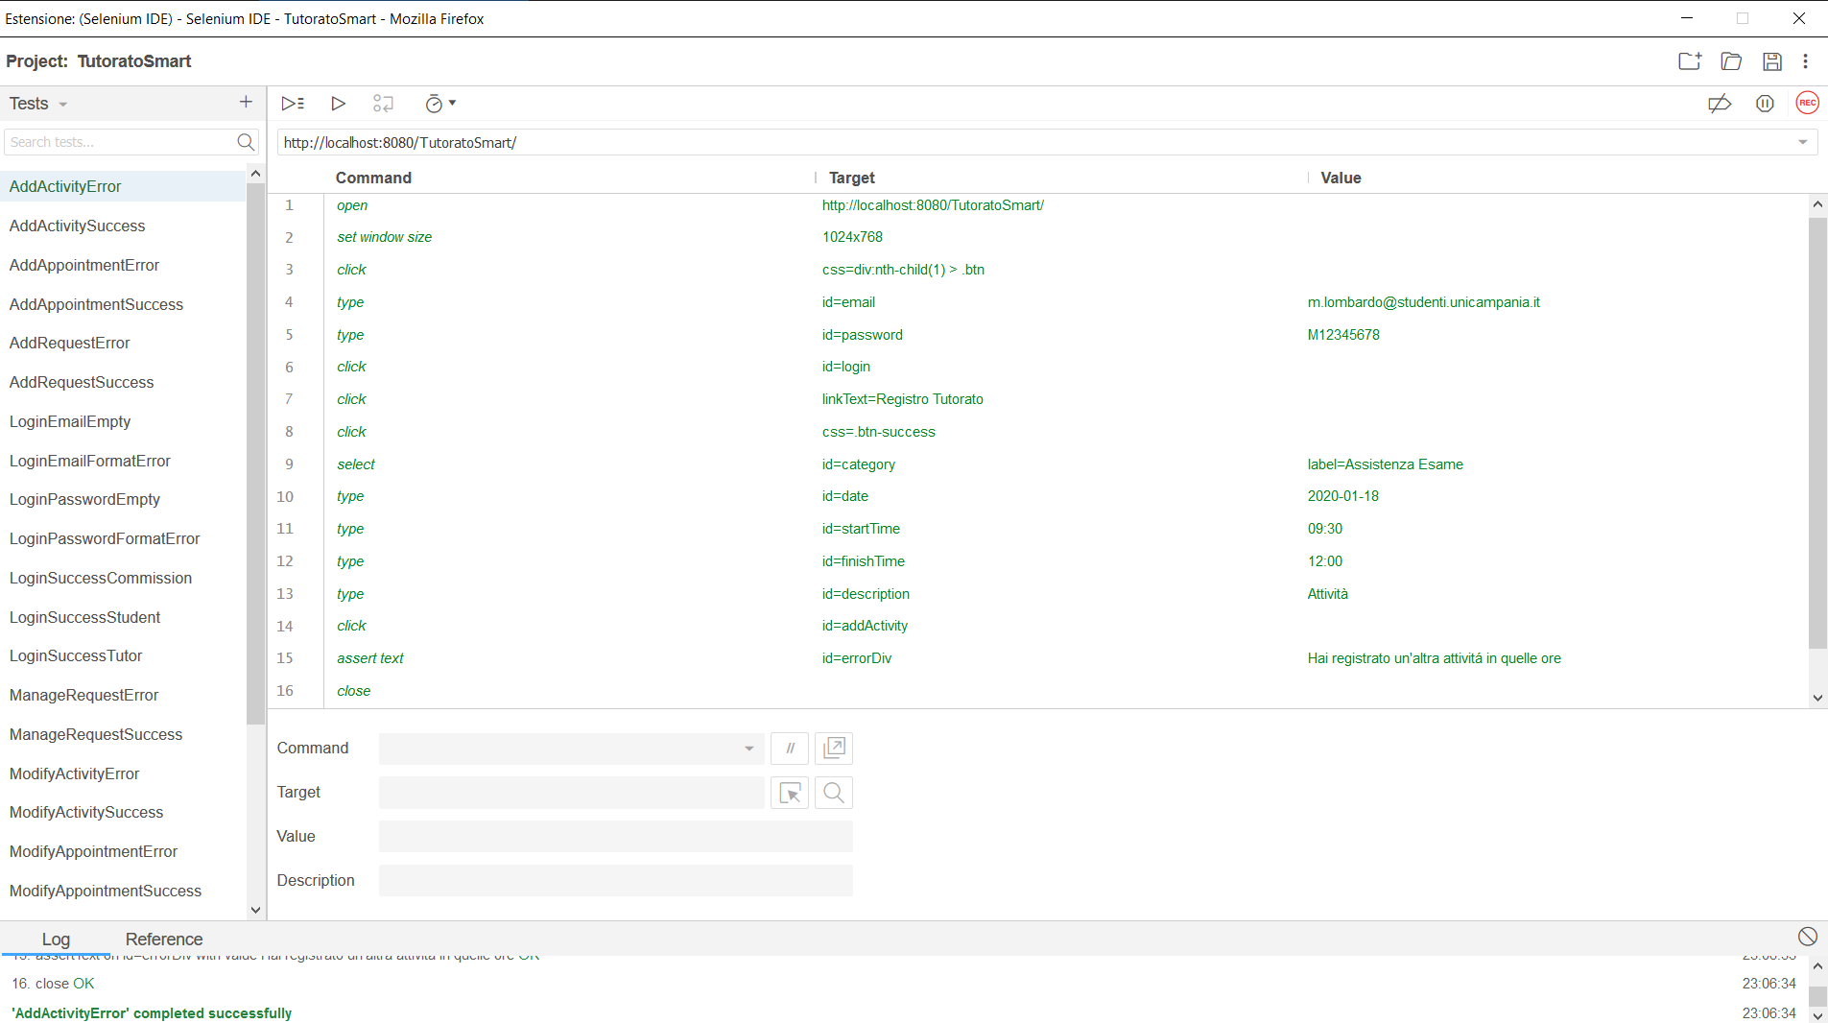

## 4.2 AddActivitySuccess

|  |  |  |
| --- | --- | --- |
| **NOME** | AddActivitySuccess | |
| **DATA** | 25/01/20 | |
| **OUTPUT ATTESO** | | |
| Corretto | | |
| **OUTPUT SISTEMA** | | |
| Corretto | | |
| **ESITO** | | Corretto |

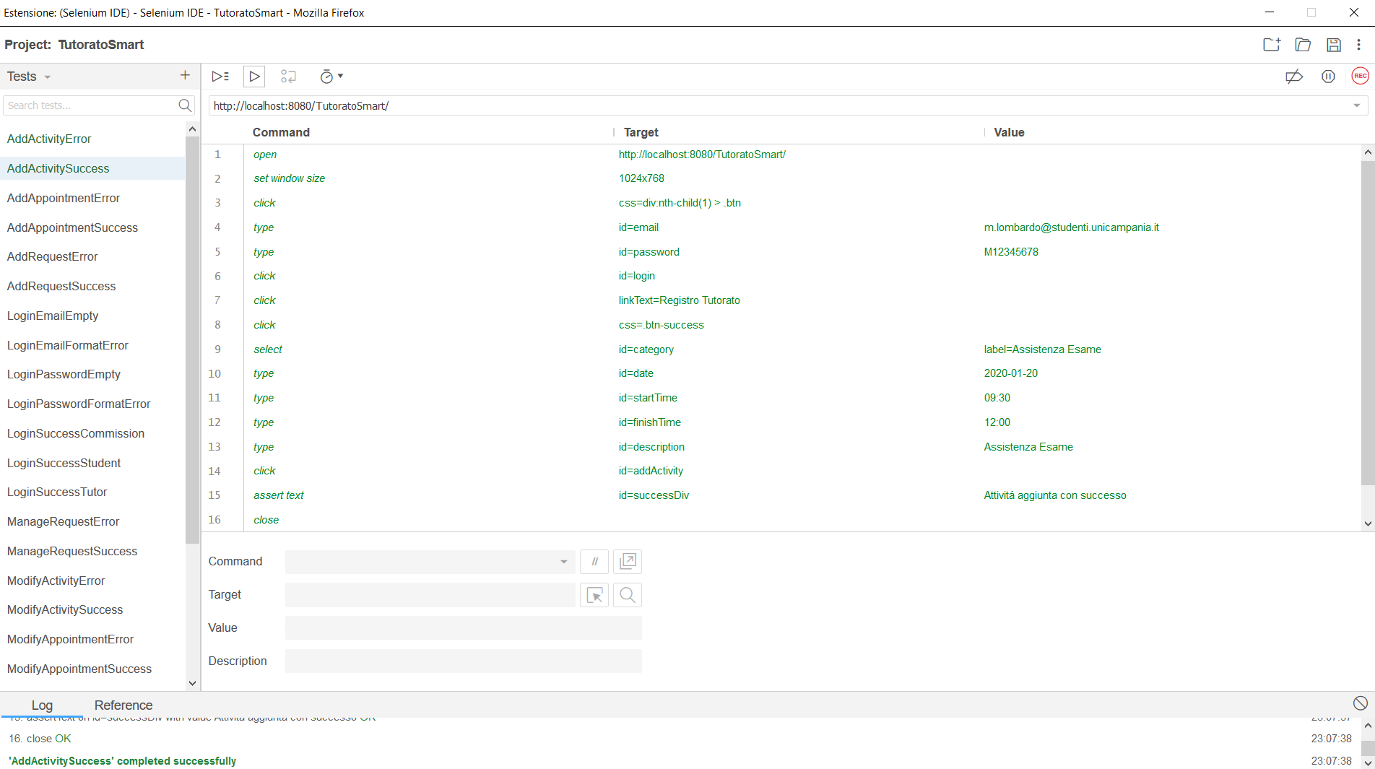

## 4.3 ModifyActivityError

|  |  |  |
| --- | --- | --- |
| **NOME** | ModifyActivityError | |
| **DATA** | 25/01/20 | |
| **OUTPUT ATTESO** | | |
| Errore | | |
| **OUTPUT SISTEMA** | | |
| Errore | | |
| **ESITO** | | Corretto |

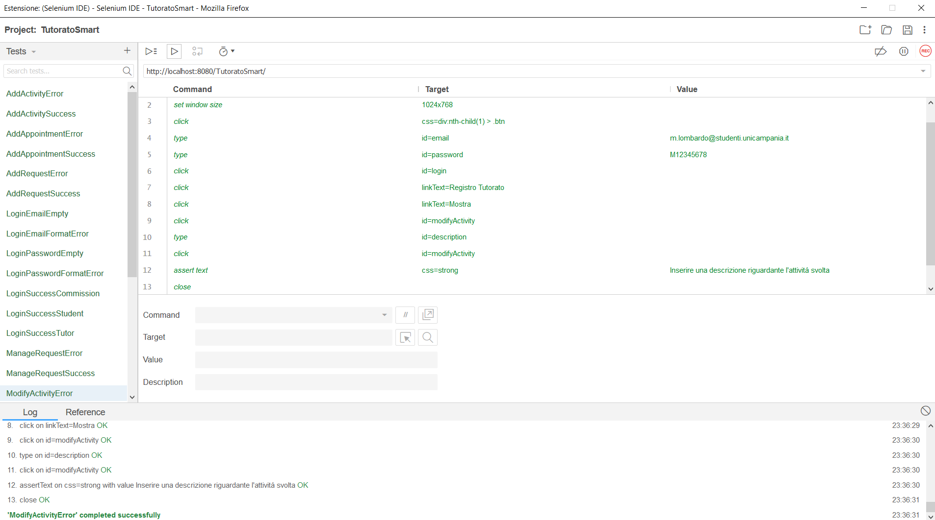

## 4.4 ModifyActivitySuccess

|  |  |  |
| --- | --- | --- |
| **NOME** | ModifyActivitySuccess | |
| **DATA** | 25/01/20 | |
| **OUTPUT ATTESO** | | |
| Corretto | | |
| **OUTPUT SISTEMA** | | |
| Corretto | | |
| **ESITO** | | Corretto |

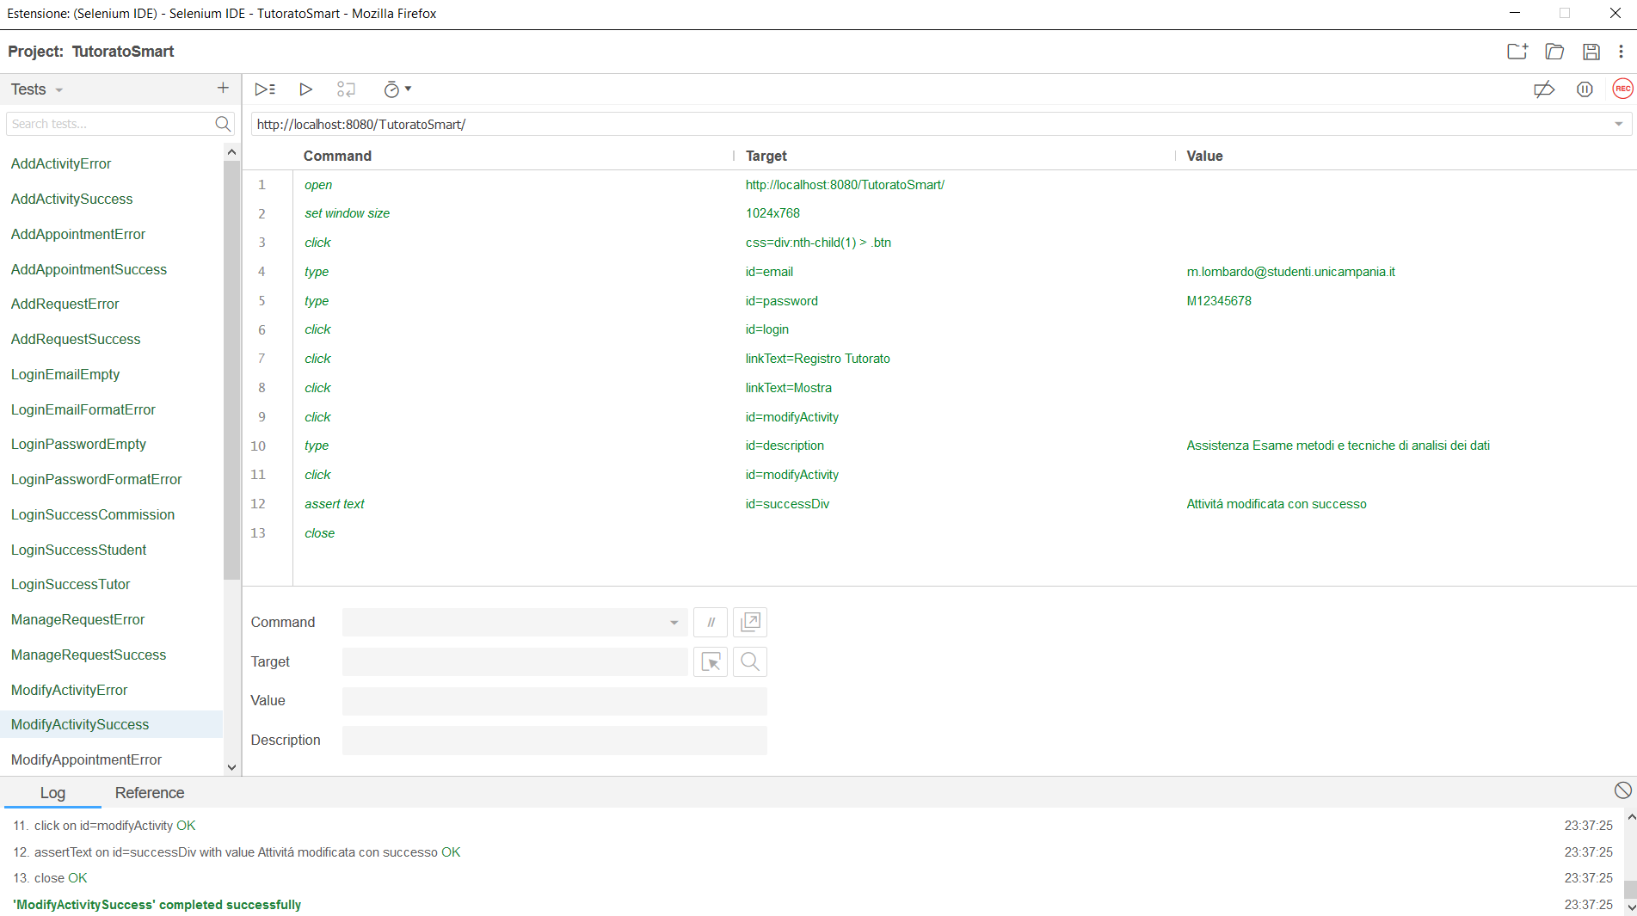

# 5. Tutoring_Supervision

## 5.1 RegistrationTutorSuccess

|  |  |  |
| --- | --- | --- |
| **NOME** | RegistrationTutorSuccess | |
| **DATA** | 25/01/20 | |
| **OUTPUT ATTESO** | | |
| Corretto | | |
| **OUTPUT SISTEMA** | | |
| Corretto | | |
| **ESITO** | | Corretto |

